1. Design and Configuration of Hybrid Topologies using Packet Tracer

Hybrid Topology using Hub:

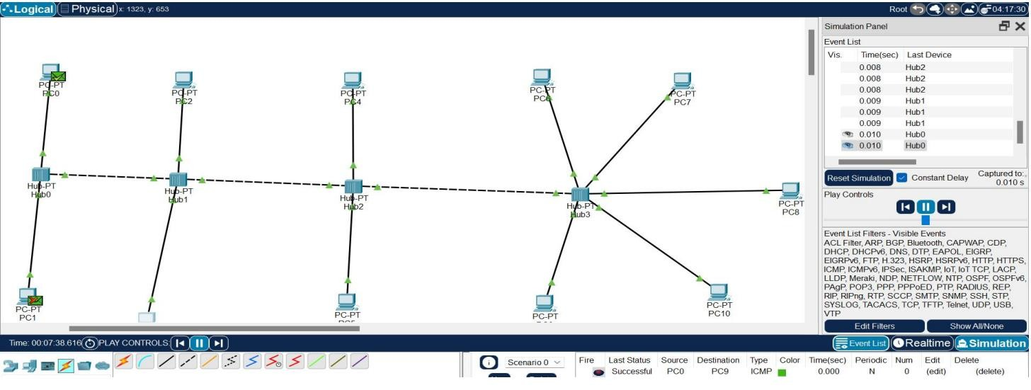

Hybrid Topology using Switch:

